Brief on Construction and Applications of

Systems Model for Simulation of Social Economy Dynamics

Based on Economic Dynamics and Agent-based Modeling

The 21st century is the era of global economy and big data. With the development of economic globalization, the economies of various countries have produced massive and rapidly changing economic information. If human beings can not solve the problem of orderly handling of economic big data, they can not make the global economy and the economy of every country develop in an orderly and coordinated manner. Using scientific economic theory and research methods to establish practical economic laboratories is the basic solution to meet the challenges faced by human beings in the era of global economy and big data. With the economic laboratory, all kinds of economic theory and economic plan can be applied in the field of economic practice only after scientific experiment and success. In this case, human economics can become a mature science like physics and chemistry. At the same time, human beings can also say goodbye to the "pat the head, by feeling, touch the stone across the river" method of economic practice. Over the years, our scientific research team has established a dynamic simulation model of social and economic system (hereinafter referred to as SED model) based on economic dynamics theory and Agents modeling method. The model can simulate the actual situation of global economy and carry out various scientific economic experiments on the basis of it. in this paper, we briefly introduce the situation of the SED model.

- Project background
- Developments in the globalized economy and modern science and technology
Since the industrial revolution in the 1860s, after years of development of global economy and modern science and technology, an information digital economic base based on new ICT technologies such as real economic system, virtual economic system, Internet, Internet of things, big data, video cloud, fusion communication, GIS 、AI and so on has been established.Next, the economic and social construction of human society will focus on the advanced development stage of building a unified economic brain.In the current development process, the modern science and technology construction of human social and economic system is mainly put into the material body part, including the construction of intelligent industry, intelligent agriculture, intelligent transportation, intelligent communication, intelligent logistics, intelligent medical treatment, intelligent education and other subsystems. When these subsystems are built, there must be a coordinated subsystem running the economic brain. Only after the completion of the construction of the economic brain, the modernization of the modern globalized economy can form a complete and closed system. Otherwise, the construction of artificial intelligence subsystems in various fields can only form various information islands. can not guarantee the coordination and orderly development of the whole intelligent economic system. Therefore, the intelligent economic brain is the key and difficult point in the construction of modern human economic society and artificial intelligence technology, and it has the key significance to affect the whole body.
- Artificial Intelligence Technology for Complex Systems
The 21st century is an era of global economy and big data. How to develop artificial intelligence technology suitable for the 21st century has become a bottleneck restricting the development of human science and technology. Currently, The world's popular artificial intelligence technology can be roughly divided into three categories :(1) artificial intelligence technology to replace human physical labor, including various robotic technologies; (2) Artificial intelligence technology to replace human simple and repetitive mental work, including intelligent statistics, intelligent finance, intelligent stock traders and other aspects of artificial intelligence technology; (3) Alternative artificial intelligence technologies for human mental work in complex systems, Such as weather forecasting systems, The "Afar" AI technology of Go, Intelligent blue army simulation technology in military systems and artificial intelligence technology in the brains of intelligent economies, etc. Of these three AI technologies, The first kind of robotics is mature, a large number of products of commercial value; The second kind of simple system artificial intelligence is in the initial development stage, There have been many successful business cases; The third kind of artificial intelligence technology is still in the exploration stage, Not many products of commercial value, But it has. Artificial intelligence technology for complex systems is characterized by, The motion process of the subjects is very complicated. The global optimal solution can not be obtained by modern computer technology. But, many local excellent solutions can be obtained by supercomputer technology and artificial intelligence computer algorithms similar to "afa dog ". These locally superior solutions have helped humans make some effective short-term prediction analyses of complex meteorological systems, For the "Afar Dog AI" to win the World Champion in the go game, Could also allow the U.S. to develop an AI pilot, Alpha AI", in simulated air combat, Defeat Air Force ace 12-0. Therefore, Artificial intelligence technology for complex systems is a feasible example of our preferred choice to build the economic brain.

3. Latest developments in international and domestic development
The 21st century is the era of global economy and big data. The global economy produces massive and rapidly changing economic information. Whoever controls economic big data controls the commanding heights of modern human society. As a result, in recent years, big data projects related to the global economy have emerged: the "digital earth" proposed by US Vice President Gore; the "intelligent earth" proposed by IBM; the "Google earth" proposed by Google; and the "virtual earth" proposed by Microsoft; The core of the 1 billion euro project funded by the European Commission is the "Future ICT Knowledge Accelerator" of the "Living Earth Simulator ", which aims to establish a global integrated scientific research platform for human social systems with a real scale at the core of the global economy, including the scientific frontiers of politics, culture, medicine, industry, agriculture, science and technology.
For many years, the research team of Guangzhou Changcheng Software Co., Ltd., with the support of the China Natural Science Foundation and the guidance of experts from the Chinese Academy of Social Sciences and the Russian Academy of Sciences, based on scientific complex theory and artificial intelligence and modern computer simulation technology, has established a computer system ——SED model of complex system economy artificial intelligence which can be applied to the practice of global economy. SED model is a closed-loop steady-state international economic simulation system, which uses the method of mechanism modeling, rule modeling and data modeling to construct the model, which can simulate the operation of the global economy in more than 100 countries, and can also simulate the economic activities of the central government, provincial, prefectural and county governments at all levels and enterprises and residents of various industries in a country every day. The main index precision of this model is over 95%, and the causality between micro- and macro-economic factors in the process of economic operation can be explained accurately and clearly on the basis of reduction method. In particular, if the Tianhe-2 supercomputer is used, it can simulate the economic process of tens of thousands of enterprises and millions of unit residents in 42 industries in the central, provincial, municipal and county of our country in about an hour. During the past 6 years, the SED model has been applied in the scientific research projects of the National Development and Reform Commission, the Chinese Academy of Social Sciences and the Guangdong Development and Reform Commission, and has been fully affirmed by domestic authoritative experts. last year, the SED model, with the support of the national natural science foundation, applied china's supercomputer —— tianhe two —— to complete the super-large scale parallel computing of 10 million simulation objects (Agents). And this means that the SED model has initially completed the transformation from theory to technology and solved the problem of batch application of software products. At the same time, it also means that our government can use the SED model to carry on the normal and high precision dynamic simulation to the economic operation process of our country and even the whole world, construct the decision frame of the top level design of our national economy, and guide the practice of socialist market economy in our country. As a result, the SED model has an international leading level in the field of modern economic big data.

II. COMPOSITION OF SED MODELS
SED laboratory is a trinity of "platform-software-supercomputer", which is based on the SED real-time synchronous remote simulation platform developed by Guangzhou Milestone Software Co., Ltd., the SED series of software, and high performance computation with supercomputer.

1. Internet-based Digital Simulation Platform
A virtual social and economic system is constructed on the Internet by the simulation platform of social and economic dynamic simulation system (SED platform). According to the needs of different users, SED platform provides different economic big data simulation support, including different interfaces and simulation environments when different types of users log in, different functions and modules realized in the course of operation based on different software models running on SED platform, and so on.All-digital computer simulation experiments with various functions can be carried out by remote calling SED model through the Internet.
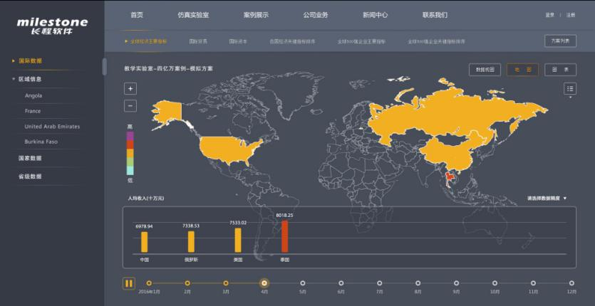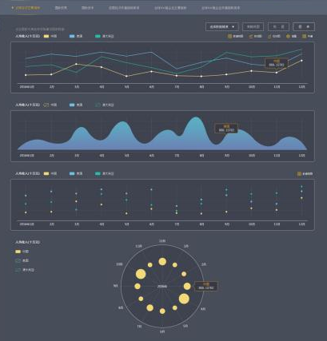

2. Simulation Software
Based on the virtual social and economic system based on the SED platform, a variety of software model versions are developed according to different needs, which can be divided into three versions: international economic model, national economic model and regional economic model.A simulation model of regional economic dynamic system (SED regional model) uses modern simulation technology to simulate the actual local regional economic operation. By constructing commodity, labor, capital and other circulation markets, the regional economy is connected into a complete national economic system.
SED regional model includes national, provincial, municipal and county administrative areas, different levels of the region has a certain attribution of jurisdiction, the same level of the region is parallel, relatively independent and economic relations. Through the specific parameter setting and characteristic data input, the actual economic situation of different regions can be simulated, including the historical operation process, the current economic situation and the future development trend, and their influence on the national economic system.

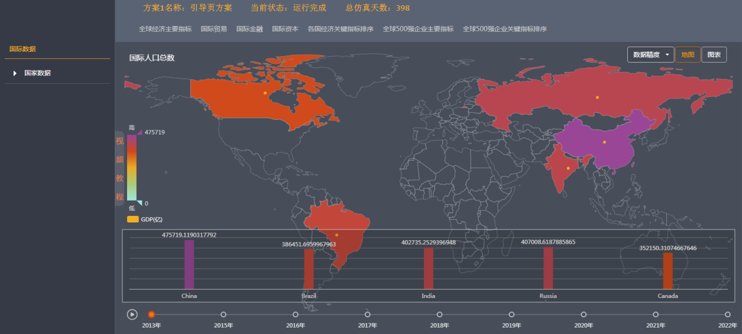

3. Hardware Environment: Tianhe-2 Supercomputer
SED model is deployed on the Tianhe-2 supercomputer at the National Simulation Center in Guangzhou, use the "strongest brain "—— supercomputer —— for parallel operations. At present SED the model has used supercomputers for parallel computing of 1000 nodes ,24000 cores or more, simulation objects over 1.7 million Agents of scientific experiments. In the experimental project, Software parallelism is nearly 80% efficient, The fidelity of the main economic indicators is over 90%. Future supercomputers can be used for more than 100 million Agents of large-scale parallel computing.
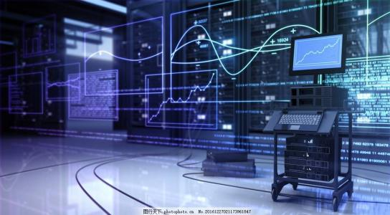

III. Basic functions of the SED model

1. the parallel control function of international, national, provincial, municipal, county and industry economy
The function of economic parallel control refers to the establishment of a computer digital simulation process which can simulate the operation of the real economy and society after inputting the relevant microeconomic data. The fidelity of the main economic index of the simulation object can be controlled at more than 95%.
The data of economic parallel control function can correspond and verify with the data of statistical department. At the same time, economic process simulation can be carried out repeatedly to analyze the relationship between different data. Provide solid and reliable technical support to the actual work of economic managers in government, industry and enterprises.

2. functions of early warning for international, national, provincial, municipal, county and industry economies
On the basis of the realization of the function of parallel economic control, abnormal economic conditions can be observed in advance, such as abnormal changes in the supply and demand relationship of certain commodities in the international economy or the national economy, abnormal fluctuation of prices, sudden loss of employment rate of residents, etc.

3. function of analyzing economic status of international, national, provincial, municipal, county and industry
On the basis of the realization of the function of economic parallel control, the economic problems concerned by the economic managers of the government, industry and enterprises can be analyzed in depth and in detail. At the same time, this kind of analysis is low in cost, fast and effective, and has strong confidentiality.

4. function of short-term forecasting for international, national, provincial, municipal, county and industry economies
Based on the realization of economic parallel control function, the current economy can be forecast monthly, quarterly and annual.

Extrapolation Function of Economic Decision-Making Effect 5. International, National, Provincial, Municipal, County and Industry
On the basis of the realization of the function of economic parallel control, we can deduce some economic decisions of the economic managers of the government, industry and enterprise, and analyze the possible effects of these economic decisions.

6. Economic Theory
Through the operation of the model, we simulate various representative economic operation conditions, and verify the rationality of some economic theorems, statistical laws and the theoretical basis for the government to make macro-control decisions, such as verifying the rationality of the Gini coefficient and the Engel coefficient.

IV. Application Plan of SED Model

Practical application is the ultimate goal of any kind of scientific and technological achievements, and it is also an objective measure to test the rationality of science and technology. A preliminary idea of how to apply SED modelling techniques in the field of economic practice is as follows:
- Construction of Economic Artificial Intelligence System
The economic brain is the central nervous system of the intelligent economic system, which combines with the existing product production system, transportation system, resident life system and information network communication system in the intelligent economic system to form an organic whole, which can make the activities of the intelligent economic system to be optimized. The ideal economic brain will consist of three parts: the basic database of intelligent economic system, the parallel control system of intelligent economic system and the command and operation center of intelligent economic system.The function of the parallel control system of the intelligent economy system is to transform the orderly information into the scientific instruction through the artificial intelligence technology of the complex system in the brain of the intelligent economy system. The function of the command and operation center of the intelligent economic system is to carry out the instructions of the command center to ensure the optimal operation of the political, economic, cultural, transportation, medical, sports, entertainment and other subsystems of the intelligent economic system.The basic database of intelligent economic system is the link between the economic brain and other subsystems of intelligent economic system, the parallel control system of intelligent economic system is the link of processing information, and the command and operation center of intelligent economic system is the link of transmitting various execution instructions to other subsystems.
Brain Chart of Smart Economies

A virtual external environment influences every virtual intelligent economy in the design architecture of intelligent economic system with SED model. This impact involves external price indices, inflation rates, unemployment rates, logistics systems, transportation systems, weather systems, changes in government macroeconomic policies, etc. All these changes will have an important impact on the smart economy system. However, in the current design architecture, we have not yet asked to connect all urban virtual systems into a unified whole, so we are not yet able to study the impact of smart economy systems on external environmental systems. Therefore, in our design architecture, the relationship between smart economy and external environment is a one-way input relationship.

(1) The basic function of the economic brain in a smart economy
- Machine generating macro-economic base database function;
- Economic development planning function;
- Economic synchronous control function;
- Early warning function of urban operation forecast;
- Research function of coordinated development of urban operation;
- city operation dynamic planning, control command function and education and training function.

(2) Clients and modes of service of the economic brain of intelligent economies
The economic brain of intelligent economy is divided into internal service object and external service object.
The internal service object is the other subsystems in the intelligent economy virtual system besides the economy brain subsystem, including the information management subsystem of each entity city component, the information communication subsystem, the database subsystem. The service mode of the internal service object is the combination of man-machine and machine connection service. The key part of machine connection mode is the application of artificial intelligence technology.
The external service targets are the various components of the entity city, including the various functional departments of the government, various trade associations, enterprises, residents. The service mode is through the regular release of economic information, the provision of economic decision advice, the provision of all-weather economic system information query services, the establishment of urban information clubs and members at all levels to achieve information sharing, to provide higher authorities with the city's economic information and economic decision-making advice, to provide modern management education and training services based on complex system artificial intelligence technology.

(3) How the economic brains of smart economies are managed
- (a) Establishing a standard data interface to establish links with the various sectors of the intelligent economy, generating physical and economic information on systems, dynamic and close-to-realistic urban human assets through the complex system of artificial intelligence systems in the brain of the economy, and eliminating information debris, information chains and isolated information islands;
- Using the artificial intelligence technology of complex system, big data clustering analysis and data mining are used to obtain orderly economic information.
- (b) Providing AI solutions tailored to the needs of government functions in each smart economy;
- To provide public economic information services, including economic forecasting, economic early warning and personalized economic advisory services, to various economic entities and residents of various intelligent economies through the complex system artificial intelligence service platform;
- A business model for project implementation is to adopt a similar PPP model: enterprise investment and construction, government purchase of services.

2. Composition of economic brain
The economic brain consists of three parts: the basic database of intelligent economy, the parallel control system of intelligent economy and the command and operation center of intelligent economy.
The base database of smart economies is the link between the brain of an economy and other subsystems of smart economies,
The Smart Economy Parallel Control System is a part of information processing,
The Smart Economy Command and Operations Center is the link that delivers various executive instructions to other subsystems.
- Relationship between the economic brain and the intelligent economy
The combination of physical cities, digital cities and smart economy operation centers constitutes a smart economy, in which digital cities consist of a digital base and an economic brain.

- The economic brains of smart economies offer locally optimized solutions
On the one hand, a large number of locally superior solutions are generated through digital cities and stored in the knowledge base of the economy's brain. on the other hand, to establish a parallel control system for intelligent economies approaching reality, in the face of various problems that are difficult to solve with the human brain, through the complex system artificial intelligence technology in the knowledge base of intelligent economies to find more optimized solutions for guiding practice.

(1) Smart economy base database
Traditional database, modern big data and machine-generated big data are combined
- Establishing an economic system simulation database with SED model output
Based on the historical process simulation data of economic system output by SED model, all economic data are required to have:
system: economic data to macro-micro integration and integration of human and property; dynamic: all simulation objects of the economic data of human and property every day; lifelike: SED model simulation output data and the statistical data of the national statistical office approximation, error rate within the prescribed range; isomorphism: economic system simulation database data structure and the existing national statistical office of the macroeconomic database data structure is consistent.
- Establishment of a database of macroeconomic statistics based on eigenvalues
Based on the statistical data of the national statistical office, it is requested that:
Representation: contains macroeconomic indicators of interest to all mainstream economics, such as GDP、 unemployment rate, inflation rate, etc.; systematic: need for macro-micro-integrated data, including statistics from various existing industries; dynamic: need to have monthly available statistics; objectivity: statistics need to be realistic and can not be artificially falsified.
- Establishment of an automatic generating system for macroeconomic data from the macro-economic simulation database and the cyclic verification of statistical database
The unity of theoretical logic and statistical results, that is, the unity of economic mechanism and realistic statistical results; the unity of data analysis results and actual situation, that is, the unity of economic meaning of macroeconomic indicators and corresponding microeconomic phenomena; and the unity of theory and practice, that is, the unity of the optimization scheme of model analysis and the successful cases of real economic process.

(2) Smart Economy Parallel Control System
- Establishing the function of economic synchronous control:
In the realization of historical simulation, on the basis of the real simulation of the digital base of intelligent economy, further simulation of the economic system of intelligent economy with macro and micro integration.Update the relevant economic data every month, one quarter, or half a year, and update it synchronously with the real international economy, national economy, China, Guangdong, and the economic system of a certain intelligent economy, which is used to study the latest developments in the economic development of the intelligent economy.
In addition, while updating the data to obtain the latest developments, timely detection of the current economic development of smart economies, as well as the original smart economy development planning problems, timely proposed adjustment programs, and formulate corresponding implementation programs.
For example, through the economic brain analysis of the Sino-US trade war, the impact of new coronavirus epidemic events on the development of intelligent economies, and the effect analysis of various decision-making programs. Clearly, predictions of major external events and different responses will have a significant impact on the development of smart economies. Through the analysis of artificial intelligence technology based on complex systems in the brain of the economy, we can obtain the results of scientific experiments accurately and quickly, assist the intelligent economy management system to make an optimized response, and achieve good management results.
- Establishment of economic early warning and forecasting functions:
On the basis of the economic synchronous control system, the mined areas of economic development are set up, and when the economic development situation shown by the system simulation data is close to these mined areas, the system makes early warning and forecast in time. At the same time, on the basis of this, the system puts forward emergency countermeasures and suggestions for emergencies, including political, geographical, climate and other external environment changes caused by the sudden changes.

(3) Smart Economy Command and Operations Centre
The Smart Economy Command and Operations Centre consists of five components: Type
- SED simulation model
The virtual social and economic system model (Social Economy Dynamic Simulation System Model referred to as the SED model) is an economic computer dynamic simulation software model which is close to the modern commodity economy and society based on the innovative modern scientific economic theory. SED model has an international advanced level of intelligent macro and micro integration of economic decision support system. Concretely, the dynamic simulation system model of national economy is based on the dynamic simulation technology of SED economy, combined with the powerful computing power of supercomputer, and establishes a virtual social and economic system which is close to the modern commodity economy and society. By simulating the operation of the international economy, national economy, regional economy and other real economic society, including government, industry, enterprise, product, price, profit, national income, resident employment rate and so on, it provides the service of economic decision support for the government, enterprise and residents by simulating the change of logistics, capital flow and personnel flow related to each economic object. The fidelity of the main economic indexes of historical process simulation is over 95%. Especially, the data source of the SED model can be connected with the digital base of the intelligent economy, and the method of data inversion is used to make the simulation results approach the subsystems of the real intelligent economy, and form a dynamic intelligent economy with high simulation fidelity computer virtual.
- Computer hardware system
including cloud computing platforms that support distributed computing structures and supercomputer systems that support large-scale high-performance parallel computing. Cloud computing platform, also known as cloud platform, refers to services based on hardware resources and software resources that provide computing, network, and storage capabilities.SED the model performs local subsystem calculations, distributed algorithms can be used for scientific calculation. Modern supercomputer systems are mainly used to undertake major scientific research, international cutting-edge technology and large-scale computing projects and data processing tasks in the field of national economy. SED model is a massively complex giant system, When doing global dynamic optimization, required high coupling and large-scale parallel computing techniques. At present, the supercomputer system of our country includes "Tianhe-1"," Tianhe-2" and" Shenwei Taihu Light ". Tianhe-1 made our country enter the top 500 supercomputers list for the first time. It's China's first multibillion - time supercomputer system, Its peak performance is 1206 trillion double-precision floating-point operations per second, Linpack measured 563.1 trillion times per second, can support SED model to complete the above computing tasks.
- Data Mining and Cluster Analysis System
After scientific calculation SED simulation model, a large amount of system dynamic data is generated. In this regard, we need to carry out various data correlation analysis, from which we need the various statistical conclusions. Modern big data systems have developed many software systems for data mining and clustering analysis from the Internet and various information channels. we can utilize these existing big data statistical analysis techniques and products.
- Artificial intelligence system
The brain's artificial-intelligence system should be an artificial-intelligence system similar to the "Afar dog ". The main components are as follows :(a) applying SED model to construct intelligent economy parallel control system to build a digital city approaching with real entity city ;(b) using computer simulation technology in SED model to generate special scenes of various types of digital cities, including different economic cycles; product life cycles of different products; various political ecological scenes; life scenes of different urban residents, such as those at different stages of an epidemic ;(c) Applying digital city technology to scientific experiments for special scenarios of different digital cities, giving solutions for local optimization of special scenarios and inputting the solutions into the artificial intelligence database, the so-called knowledge base storage; and (4) rapidly providing scientific solutions for decision-making support by various service objects in the brain of an economy through artificial intelligence database queries when certain similar urban operating scenarios occur in real cities ;(d) To generate new solutions, update AI databases, upgrade AI databases and provide more advanced services.
- HMI sand table extrapolation system
Through the confrontation and contest between the Red and Blue armies on the battlefield, the traditional chess table shows the problems existing in the strategy and tactics of both sides, and improves the commander's combat ability. Britain and the United States well-known business schools and management consulting institutions quickly realized that this method is also suitable for enterprises to train and exercise senior managers, and then the military chess deduction for extensive reference and research. In recent years, with the improvement of computer computing ability, Bing chess deduction has developed computer all-digital simulation sand table deduction and human in the loop semi-physical simulation soldier chess deduction. Now, we have transplanted this technology into the brains of the economies of the smart economies, and we have trained the smart economies to optimize their management-a new model of modern decision support.
To sum up, the economic brain is the central nervous system of the intelligent economy, focusing on solving the optimization problems of various types of local information collection, information processing and coordinated operation. It must be emphasized that all the optimization functions of the economy's brain are, in the final analysis, to convert the various information collected in the digital base of the intelligent economy into economic information, and to formulate the most favorable solutions for the overall development of the city according to the principle of maximization of benefits. In particular, the ultimate goal of building the brain of intelligent economy is to change the spontaneous and disorderly state of modern urban operation, and instead to make urban operation subject to the control of intelligent brain, and to become an intelligent system for the sustained, stable and rapid development of economy with controllable and optimized operation. That is to say, the optimal function of the economy's brain in governing the city and serving the citizens must be reflected in the sense of acquisition and experience of the urban residents, which is ultimately expressed through sustained, stable and rapid economic development. In addition, the construction of the brain of an economy should not be applied only at the urban level, but also at the district level, including the township level. There is also that the whole data must be integrated, government data, Internet of things data such data can be unified management, and then co-ordinate the whole information resources sharing mechanism, including collaboration mechanism.The brain of an intelligent economy needs to form a closed loop from problem discovery to problem analysis to problem solving, and the whole process needs to be visualized.

3. Expected objectives
Brain building in economies based on SED models will address the following:

(1) Economic development planning issues:
The economic brain provides strong decision support for urban planning through natural and economic, social, cultural, demographic and other human and social information mining, such as urban geography, meteorological information, to strengthen scientific and forward-looking urban management services.

(2) Intelligent management of economies:
The economic brain connects data resources scattered across urban units, connects urban neural networks, and allows data to help cities think, make decisions, and operate to achieve urban management and social governance.

(3) Economic optimization issues:
The economic brain promotes the research, development and application of big data in various fields of economy and society through the organization and management of economic and social data resources, and further promotes the transformation and upgrading of urban industries and the optimization of economic structure.

4. Expected accomplishments

(1) Development of a base database for smart economies
Realizing the mining of natural and economic, social, cultural, demographic and other human and social information, such as geographic and meteorological information of economies, linking data resources scattered across urban units and connecting urban neural networks

(2) Development of parallel control systems for smart economies
Realize the parallel operation of the intelligent economy system twinned with the real economy numbers, connecting the real and virtual interaction between the real economy and the intelligent economy

(3) Establishment of a Smart Economy Command and Operations Centre
To provide decision support for urban planning and improve the rationality and economic benefit of decision-making
Intelligent urban management and social governance
Optimizing the allocation and management of economic and social data resources

V. A case-specific programme

Recently, the SED model has a practical application case related to the economic intelligent system system of county intelligent city. Below, we contact this practical application case to introduce the specific application of the project.

Economic brain system 1. a county-level intelligent city
Basic configuration: Simulation of national, provincial, municipal and county-level economy, using at least 7 supercomputers high-performance computing nodes
Data requirements:
- National and provincial statistical yearbooks, input-output tables
- City Statistical Yearbook, Input-Output Table
- County Statistical Yearbook, Input-Output Table
- The output value of the top ten industries and the financial statements of the top ten enterprises in each industry
The realistic degree of the economic index of the country, province, city and county administrative area which is output by simulation reaches the established standard
Realizing the function of pre-judgment of economic development planning and decision-making effect
To predict the benefits of different economic decisions, the difference between different decision-making schemes can reach tens of millions or even billions of dollars
Simulation of economic response measures in different economic scenarios, such as the epidemic situation, different levels of resumption of work and production on the economic impact of different
Through scientific and forward-looking prediction and analysis, we can improve the rationality of decision-making, help local enterprises to improve economic benefits and promote the increase of local government financial revenue

(1) Probationary programme
More than 80% of the economic indexes of the national, provincial and municipal administrative regions are simulated
The simulation fidelity of the economic index of the county administrative area which realizes the simulation output is over 90%

(2) Formal applications
More than 90% of the national, provincial, municipal and county administrative regions that realize the simulation output within 3 months
Within half a year, the fidelity of the simulation of the main industrial economic indexes of the county-level administrative region which realizes the simulation output is over 90%
The simulation fidelity of the economic index of the leading enterprises in the county-level administrative region which realize the simulation output within one year reaches more than 90%
Compared with the rational expected goal in the future, the simulation proposal scheme can reduce the investment risk by 10% and increase the economic benefit (enterprise income, government tax) by more than 3%

2. construction period

(1) Light assets programme:
In the construction of intelligent city, it provides remote control service of economic brain, and provides the processing and analysis of urban economic big data for the national / provincial / municipal / county government project of building local intelligent city, so as to assist the planning and execution of urban or town management decisions.
The construction period of a pilot project in the early stage is 5-6 months, and after the completion of 3 pilot projects, the construction period of each new application point will be shortened to about 2 months.
The project team is equipped with 10 people ,5 of whom are calibrated in the base period, and 5 of whom are assisted in decision making. After each update of the data, the calibration period for completing the base period data is about 3 months.
Five major decision-making exercises are provided free of charge every year according to the standard of formal application scheme, and the correlation analysis and information entropy analysis of simulation output data are provided.

(2) Heavy assets programme:
In the national/provincial/municipal/county government project to build local intelligent city, the field construction of the economic brain command center, seamless connection with the digital base of the local intelligent economy, the establishment of economic synchronous control function, artificial intelligence deduces the social and economic benefits of different economic decisions under various economic scenarios to assist the planning and implementation of urban or urban management decisions.
The construction period of a pilot in the early stage is 1-2 years. After the completion of 3 pilot projects, the duration of each new application point will be shortened to about 6 months-1 years.
The project team is equipped with 20 people ,10 of whom are calibrated for the base period and 10 for decision deduction. After each update of the data, the calibration period for completing the base period data is about 1.5 months.
Five major decision-making exercises are provided free of charge every year according to the standard of formal application scheme, and the correlation analysis and information entropy analysis of simulation output data are provided.

2. the Solutions of Government's Intelligent Decision-making in Macroeconomics
Big data-based big economic problems
Bing Qi (Wargame), traditionally regarded as a tool for war extrapolation, is actually a new methodology to help decision makers find solutions to difficult problems. Military chess deduction is a kind of pre-practice, which can conduct virtual exercises and analysis on the asymmetric conflicts, security threats and fierce global competition faced by the world today.

(1) Purpose
Finding problems and optimizing decisions: finding weaknesses, optimizing plans, etc.
Training of decision makers and managers: familiar with possible crisis situations, command processes, etc.

(2) Advantages
Military chess deduction can provide realistic decision-making conditions
It's not "playing chess ". The presenter does n' t have all the information; he simulates the realities and possibilities
The military game provides a near-real dynamic environment
Confrontation best inspires creative thinking, and "decision makers" are responsible for the consequences of decision making, unlike static expert argumentation
Military chess deduction can provide comprehensive and complete virtual practice means
Virtual practice is carried out in advance to train decision makers and decision-making organizations to achieve "first count and then win"

(3) Applications
Developed countries in the West, especially the United States, are a common tool for think tanks to study problems
Social administration
Political and economic management
Military and war management
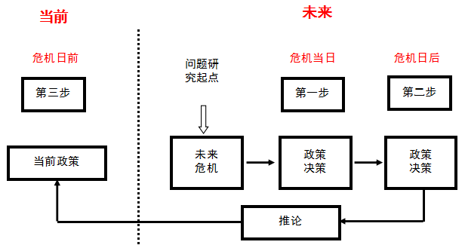
How to deduce chess: the "future "(Day After) law of rand

(4) Main research contents of military chess deduction
- Scenario design
- Deduction: the setting of the deduction, the selection of the deduction personnel, the setting of the deduction process and the way of walking table, the way of the director's ruling
- Platform design: situation system, model and rule system, command and decision system, discussion system, intelligence system, clock system, adjudication system, control system, planning and analysis system, etc.
- Data engineering
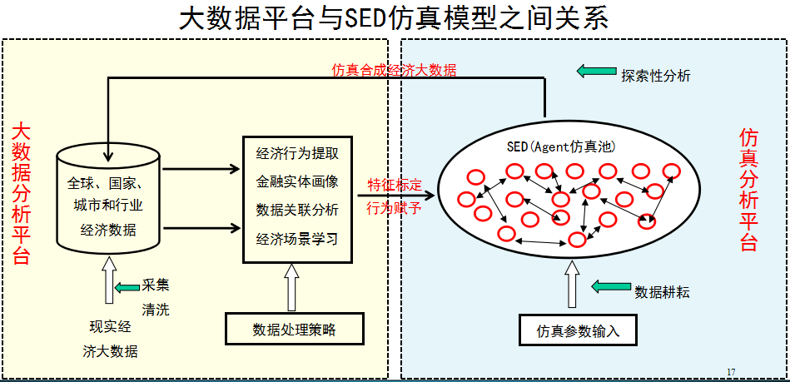
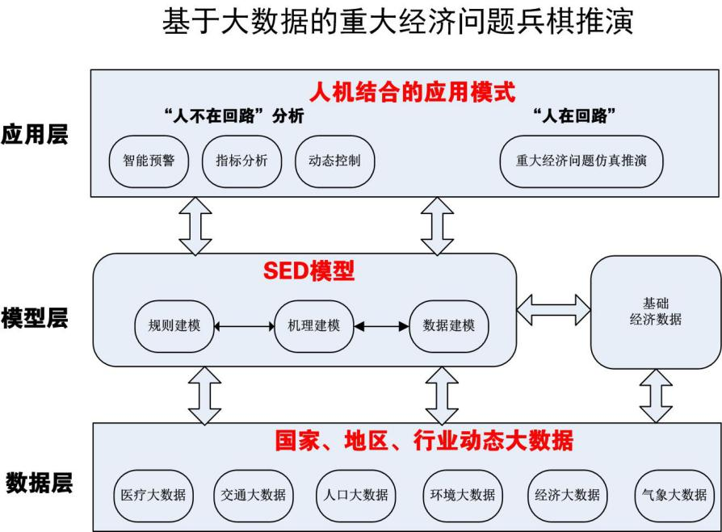

(5) Steps of military chess deduction
Step 1: Look at the initial situation
According to the idea of generating the initial situation T0 the performers watch the initial situation on the large economic screen of computer simulation laboratory (full digital simulation economic situation system, macroeconomic system, microeconomic system, enterprise economic system)
Step 2: Review the situation and deal with it
According to the initial situation, the rehearsal personnel analyze the response, suspend the simulation model, make countermeasures and suggestions and submit to the director department step 3: director ruling
After the model is solved or the expert decides, the relevant instructions are input into the computer software model, the operation is resumed, the situation is formed Ti, and the new situation is displayed to the extrapolation staff
Step 4: Re-examine the situation and deal with it. Step 3
Step 5: Analyze and summarize to form a conclusion
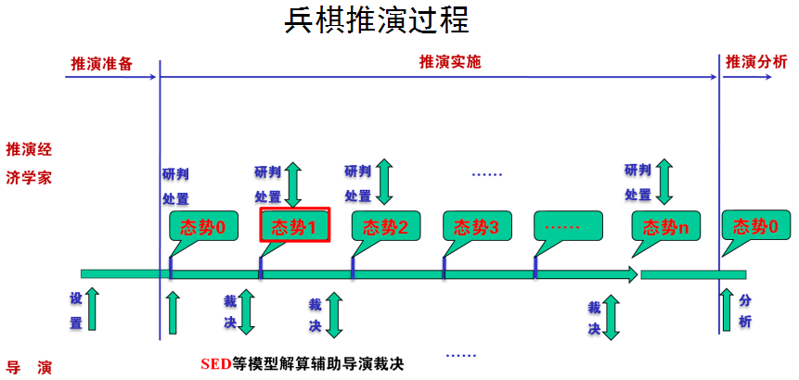

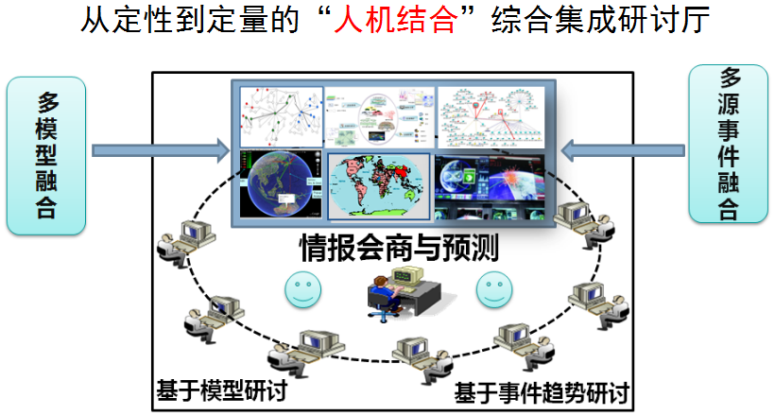

3. data requirements

(1) Data sources:
- Basic authority database
At present, the basic database of every city in our country is composed of data information and category data information of authoritative departments such as government.Among them, the department data information reflects the information collected, cleaned and compared from each department, and the storage of the information is divided according to the data department source; the category data information is stored according to the economic, social, resident life and other data types, and the information of the same data category can be derived from multiple departments.
- Information industry big data platform
"Big data" means that relying on cloud computing distributed processing, distributed database and cloud storage, virtualization technology, from the traditional industry database, Internet and traditional statistical analysis channels to obtain a large amount of raw unstructured and semi-structured data, massive data distributed data mining and cluster analysis, so as to obtain economic value of information assets. Big data is a collection of data that is large enough to exceed the capability of traditional database software tools in terms of acquisition, storage, management and analysis. Big data has four characteristics: massive data scale, fast data flow, diverse data types and low value density.
- Machine Generation Data Method
This method uses the combination of mechanism modeling, rule modeling and data modeling to generate a full digital simulation model approximated by the physical system or economic and social system of the real society, and then by obtaining the micro-basic data input model in the real statistics, so as to generate the various intermediate and final variables of the real social physical system, or the multi-level subsystem of the economic and social system systematically. On the basis of the big data system generated by this machine, the reference frame established by the key node data in the various statistical data in the real physical system or the economic and social system is further calibrated to repeat the data, and to ensure the approximation between the machine generated data system and the real system. Various teaching laboratories of modern physics, computer digital simulation models of various engineering projects, and meteorological forecast models are all of this type of models. At present, in the field of simple and stable physical process simulation, the method of machine generating big data has been very mature. However, applications in complex systems are still at an early stage of development. A successful example is the weather forecast model.

(2) Smart City Digital Base:
The economic brain is attached to the digital base of a smart city, just as a person's brain is attached to his body. At present, after years of development, the construction of intelligent city in China has formed a relatively perfect technical foundation system. Here, the digital base of the Smart City is a bottom-up system:
- Material elements of a smart city, such as quantity, quality and time;
- Material elements constitute material units, such as raw materials, equipment, products, currencies, prices;
- The intelligent subject composed of material units includes residents, enterprises and government departments.
- There are many industries with local intelligent information management functions, such as manufacturing, logistics, transportation, communications, commerce, finance, medical entertainment, sports and education.
- Different industries constitute the industrial circulation chain subsystem, including industrial subsystem, transportation subsystem, communication subsystem and so on.
In the intelligent city, these industrial chain systems are interrelated, and the division of labor and cooperation, their respective duties and responsibilities are indispensable, just like the digestive system, sports system, endocrine system, circulatory system, respiratory system and so on in a human body.

Economic Simulation Base of National Simulation and Control Engineering Research Center
Guangzhou Milestone Software Co., Ltd.
5 July 2020

